Excerpts from zoning use table found on Chamblee’s MuniCode (Linked Here):
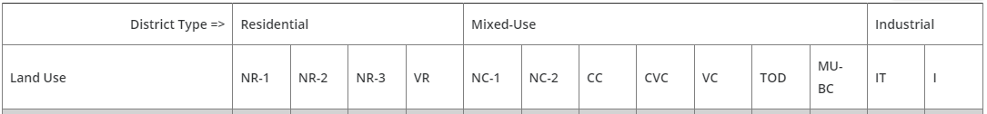

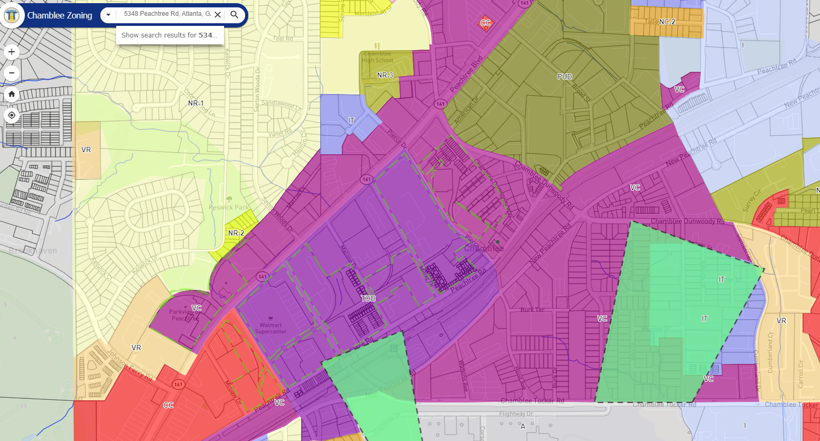
Screenshot from Map found in Chamblee’s Interactive Zoning Map (Linked Here):

